**-:Create a local Git repo for your Eclipse project:-**

Before you can push your project to VSTS, you need to add it to a local Git repo.

Note: If your code is already in a local Git repo, you can skip this step.

1. Right-click your project name in Project Explorer and select **Team, Share Project...**Select **Git** and select **Next**.
2. Select **Create...** from the **Configure Git Repository** window and choose a folder for your local Git repo. Select **Finish**.

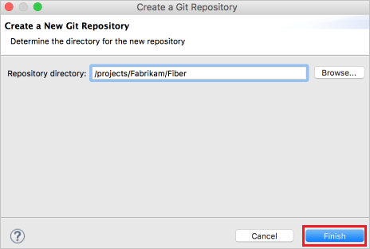

1. Right-click your project in Project Explorer and select **Team, Commit...**. Stage your changes by dragging your files to the **Staged Changes** field, enter a commit message, then select **Commit**.

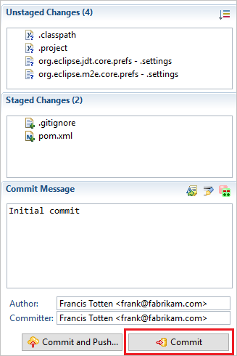

Push your project to your VSTS/TFS repo

1. In Team Explorer Everywhere, select **Git Repositories**, then right-click the empty repo you want to push your Eclipse project to and select **Copy Clone URL**. If you don't have an empty Git repo created in VSTS/TFS yet, you can create one using [these instructions](https://docs.microsoft.com/en-us/vsts/git/create-new-repo).

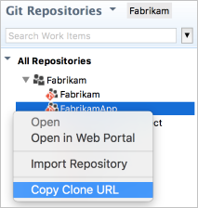

1. In Package Explorer, right-click your project and Select **Team, Push Branch ...** . Paste the clone URL from the clipboard into the **URI** field and select **Next**. Make sure **Configure upstream for push and pull** is selected in the next window and select **Next**.

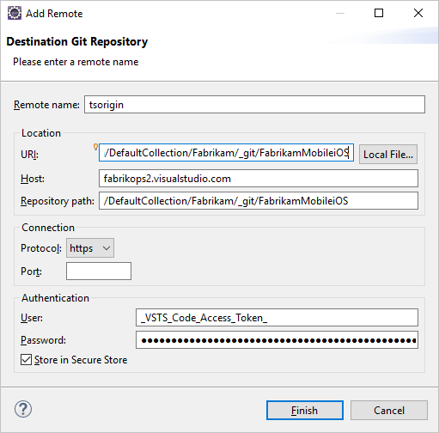

1. Review the changes and select **Finish** in the **Push Branch** window.

Your project code is now your VSTS Git repo.